

CSAI413 Project - Retrieval Augmented AI System
FitRAG - Fitness AI Assistant



Team members
Meshal Alrajaby - 22000101
Essam Al Sobeh - 22000882
Ahmed Abdulaziz - 22000427
Mahmoud Mahoud - 22000796

Submitted to Professor Andrea Rojas
On 26/05/2025

Introduction
This report presents our design and implementation of the Retrieval Augmented Generation system for our fitness domain FitRAG. This modern AI architecture combines the information from a specific source (PDFs) and the ability to generate cohesive sentences using the Large Language Model (LLM). Our goal with this project is to evaluate the design decisions, behavior and figure out any limitations.
Our chosen domain is fitness. The system will be designed to help you with your questions related to exercise programming, workout principles, and sports science. The user may ask “How many times should I train as a beginner” or “what does progressive overload mean and why is it important”, and will receive an answer directly taken from the knowledge base. This system would target individuals who have limited knowledge in fitness and seek reliable and easy to understand information. These individuals often struggle to get simple knowledge when there is overwhelming and often contradictory fitness advice available online, one source might suggest a certain workout routine or certain days to train with no reasonable justification. Our RAG system would be able to confidently give a response with cited sources.
Someone may ask why use a domain specific RAG system instead of general-purpose LLMs, LLMs generate responses based on patterns found in the training data, predicting the next words with little to no reason on why and only the probability of the word. Meaning it cant tell why you should be training 3 or 4 days a week as a beginner in the gym. Also LLMs are prone to hallucinations, meaning it might sound confident generating a response but be totally wrong. Therefore using a RAG system for a specific domain is better than direct LLMs in terms of more accurate and source grounded informatoin.

Dataset Description
We chose 10 fitness related documents for our knowledge base spanning three distinct categories, Official health and physical fitness, peer-reviewed sports science research papers and practitioner facing strength and conditioning resources. Hopefully the system would be able to handle diverse questions from general activity recommendations to technical training methodology.
Here is a list of our current corpus:
Title | Authors | Type
WHO Guidelines on Physical Activity and Sedentary Behaviour | World Health Organization | Health Guideline
Increasing Anaerobic Endurance Using Strength Endurance Training and Continuous Running on Muscular Endurance | Hajarudin et al. | Research Paper
Progressive Overload in Long-Term Exercise Interventions Targeting Executive Function: A Scoping Review | Manuscript KR.2025-0024.R2 | Research Paper
Progressive Overload (CEU Quiz) | National Council on Strength & Fitness (NCSF) | Training Resource
Who Wants to Be a Novice? You Do | Mark Rippetoe | Training Resource
Youth Resistance Training: Updated Position Statement | Faigenbaum et al. | Position Statement
NSCA Position Statement on Long-Term Athletic Development | Lloyd et al. | Position Statement
Resistance Training for Older Adults: Position Statement | Fragala et al. | Position Statement
NSCA Position Statement on Weightlifting for Sports Performance | Comfort et al. | Position Statement
NSCA Strength and Conditioning Professional Standards and Guidelines | NSCA Task Force | Professional Standard

Preprocessing
Our Knowledge base contains 10 PDF documents that were loaded by PyPDFLoader from LangChain. Which extracts text page by page and still preserving source metadata like the filename and page number. In total we had 305 pages before any preprocessing.
These are the cleaning steps we have applied on all pages
- Page number removal
- Remove any 3+ consecutive
- White space normalization

Chunking Strategy
After we cleaned our pages from unnecessary noise. Pages were split into chunks using RecursiveCharacterTextSplitter from LangChain. It divides text on natural bounderies including double line break \n\n and single line break \n and full stops and spaces. This ensures that chunking would happen at natural paragraph or sentence boundaries instead of chunks being mid sentence or mid word.
The baseline parameter would be:

Parameter | Value | Justification
Chunk size | 512 characters | Captures a complete and long paragraph or sentence that holds information to be semantically meaningful.
Chunk overlap | 50 characters | Maintaining continuity between chunks and preventing loss of context
Minimum chunk length | 100 characters | Filtering non meaningful chunks like headers, footer and labels
After applying these parameters on our 305 pages, it produced 3074 chunks, averaging a length of 453 characters per chunk.
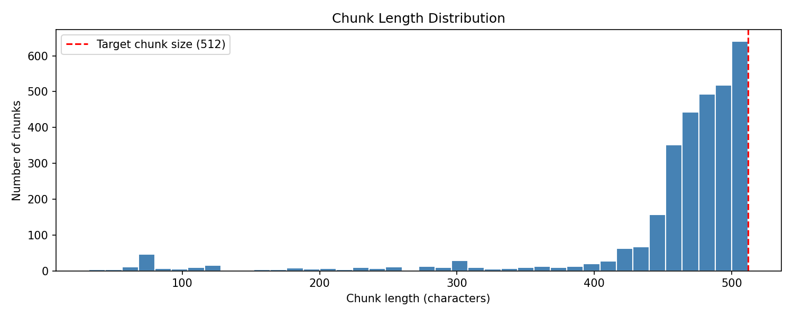

System Architecture
- 3.1 Pipeline overview diagram

Components
- Document Loading: This components ingesting raw PDFs, the files are loaded using LangChain’s PyPDFLoader, which parses the PDF binary and extract text content page by page, it also preserves the PDFs metadata like filename and page number. These metadata are also kept with each chunk allowing the system to retrace any generated answer to the exact source document.
- Text Cleaning: Raw PDFs always contain information that won't be relevant or helpful in our vector store. Often lowers retrieval quality. Removing such as page number, excessive line breaks. Long spaces. Overall reducing unneeded noise from PDFs.
- Chunking: LangChain’s RecursiveCharacterTextSplitter used for breaking down page content into smaller chunks while still maintaining full paragraphs or sentences for information holding, rather than mid sentences or mid word. Still maintaining the metadata for trace backs.
- Embedding Model: Each chunk is converted in a dense vector representation using an text embedded model. These vectors capture the semantic meaning behind each chunk, chunks that share the same concepts will have geomatrically close in the embedding space.
- Vector Store Index: The chunk embeddings are stored in a vector index. Which helps with finding nearest K neighbors. When a user asks a question, the embedding model converts the query into a vector, and the index used to perform a nearest K to find relevant chunks to the user questions.
- LLM Response Generation: an LLM would be used to generate a natural response to the user query based on retrieved information, including the source of the information like which document and which pages the answer was drawn from.
- Evaluation: Evaluate the systems based on 4 things. Retrieval Relevance, Answer Correctness, Groundedness, Robustness.

Design Justification
The embedding model that was selected for our baseline is multi-qa-MiniLM-L6-cos-v1. Its a 6 layer transformer model from sentence-transformers. The output is encoded as a 384-dimensional dense vector. We chose this mode over the general alternative because of its training purpose. The all-Mini-L6-v2 is trained on general sentence pairs, while our chosen model was fine-tuned on multi-domain question-answers datasets.Also the model was optimized for cosine similarity hence the -cos- in the model name.
For our retrieval approach. We will use FAISS (Facebook AI Search Similarity) dense vector search with Maximal Marginal Relevance (MMR). Upon initial testing with the standard cosine similarity retrieval (k = 5) revealed a consistent redundancy problem where we asked “How many days per week should a beginner train ?”, where two retrieved chunks were from the same document and from consecutive pages. Here MMR addresses this issue by penalising chunks that are similar to already selected chunks,
We considered another retrieval approach that we found in a different course on the project idea. Which is the BM25 sparse retrieval, but this doesn't capture semantic meaning and it only looks for keyword overlap. We might combine this with Dense, creating a hybrid retrieval, this is also mentioned in the other course project brief.

Baseline Implementation
The baseline system was first implemented across three jupyter notebooks for easy debugging and readability. The full pipeline connects the vector store from Notebook 2 to a LLM with a structured prompt for enhanced response generation. The system was proven to be working with the following configuration that was saved in retriever_config.json:
- Embedding model: multi-qa-MiniLM-L6-cos-v1
- Vector index: FAISS indexFlatL2, 2997 vectors, 384 dimensions
- Retrieval strategy: MMR, k=5, fetch_k=20,λ=0.5
- LLM: llama-3.3-70b-versatile
- LLM temperature: 0
- Max output tokens; 1024
This is our structured prompt.
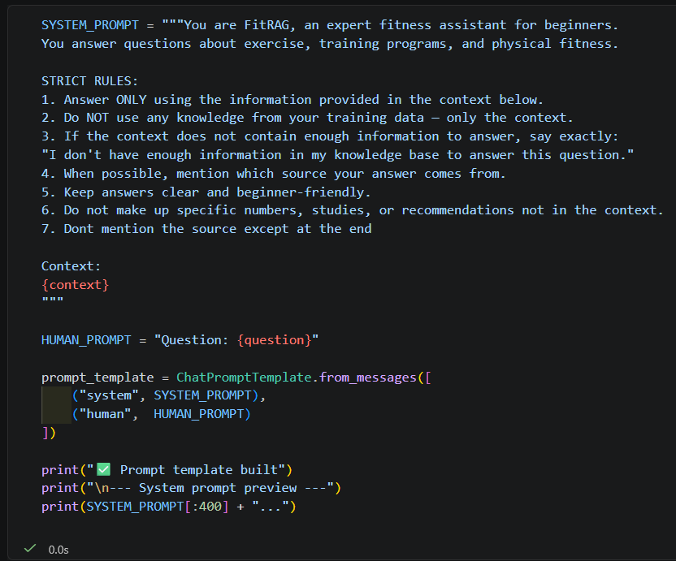

Example queries
- Query: How many days per week should a beginner train?
Generated response: A beginner should train 2-3 days per week. This allows for sufficient recovery time and is considered optimal for novice trainees.

This was a direct question and the system managed to retrieve 3 out of 5 relevant chunks and the generated answer was corrected and brief.

- Query: What is progressive overload and why does it matter?
Generated response: Progressive overload refers to the gradual increase of stress or resistance on the body during exercise to promote adaptation and improvement. This can be achieved by manipulating variables such as speed, resistance, or repetitions. It matters for beginners because it allows them to continuously challenge themselves and make progress in their fitness journey. By gradually increasing the intensity of their workouts, beginners can improve their overall fitness and strength, and reduce the risk of plateaus.

This was a more of a conceptual type of question, yet it retrieved 5 out 5 relevant chunks strengthening the knowledge for the LLM. and the answer was an excellent response

- Query: How should a beginner structure a full week including rest days?
Generated response: A beginner should structure a full week of training to include at least 3 days of vigorous-intensity aerobic activities, as well as those that strengthen muscle and bone. It's recommended to start with small amounts of physical activity and aim for moderate- to vigorous-intensity physical activity across the week, with most of it being aerobic.

This query is a Multiconcept type question and the system was able to retrieve 4 out of 5 chunks relevant to the question and the response was fully grounded as in all information was fully supported from the relevant documents

- Query: How many sets and reps should a beginner do per exercise?
Generated response: A beginner should perform 2-3 sets per exercise. The recommended number of repetitions is 10-15 at a lower relative resistance.

This was a specific and factual type of question, but the system was only able to retrieve 3 our of 5 chunks relevant to the question. And the answer was fully grounded.

- Query: What is the best workout?
Generated response: I don't have enough information in my knowledge base to answer this question. The context provides general guidelines for working out, such as starting with light loads, focusing on proper technique, and including exercises for all major muscle groups, but it does not specify a single "best" workout.
This was a different question compared to the other, it was very ambiguous therefore the system
Was able to refuse to give an answer and avoid hallucinations.

- Query: What should I eat before a workout to maximise performance?
Generated response: I don't have enough information in my knowledge base to answer this question.

This was also a different type of question, but this one was out of our domain, a nutrition specific question and the system was able to answer and inform the user of not having enough information despite it being a LLM that would be able to answer but a RAG system ensures a fact-based answers only.

Initial Evaluation
Across the six baseline queries, the system faced three different behavioral patterns, for clear in-scope queries with strong source coverage. The system performed well and returned an accurate, multiple sentence grounded answer. For queries where relevant information existed but were mixed in irrelevant chunks. The systems still produced somewhat correct answers, indicating the LLM was able to filter useful context from noise. Lastly for ambiguous and out-of-scope questions, the systems successfully refused to answer rather than hallucinating
The system showed three types of failure.
- Retrieval: Keyword-driven false positives: on query 1, the system retrieved 2 irrelevant chunks, both of them matched surface level terms like weekly training but it discussed unrelated topics. This occurred on other queries as well, meaning a systematic retrieval weakness rather than a single incident. 1
- Ambiguous Query: No Clarification Mechanism: on query 5, the was able to respond with a generic refusal since the keyword ‘best’ weren't in the knowledge base, but it would be better to if the system would make the user ask a clarifying question.
- Out-of-Scope: Uninformative Refusal: on query 6, here the system was able to confirm its ability to not hallucinate, but the refusal leave the user with a dead end response.
We have also identified limitations that would be addressed in the next deliverable.
- Insufficient text cleaning: some chunks contain headers, links and watermarks, this might degrade the embedding quality
- Chunks size: at 512 characters, chunks might contain multiple topics, this directly impacts the false positives retrieved documents
- No quantitative evaluation

Project Repo
GitHub: https://github.com/Meshal6299/FitRAG
Note: the repo has 3 notebook, 01_preprocessing.ipynb for document loading, cleaning and chunking, 02_embeddings_indexing.ipynb for building the FAISS vector store and testing the retrieval before proceeding. 03_baseline_rag.ipynb for the end to end RAG pipeline including the LLM response generation.
Also the pipeline will have a standalone rag.py that would take a user input and give a response via the terminal and another app.py for running a streamlit UI that wraps rag.py for an interactive user experience allowing user to also see relevant document related to the question

